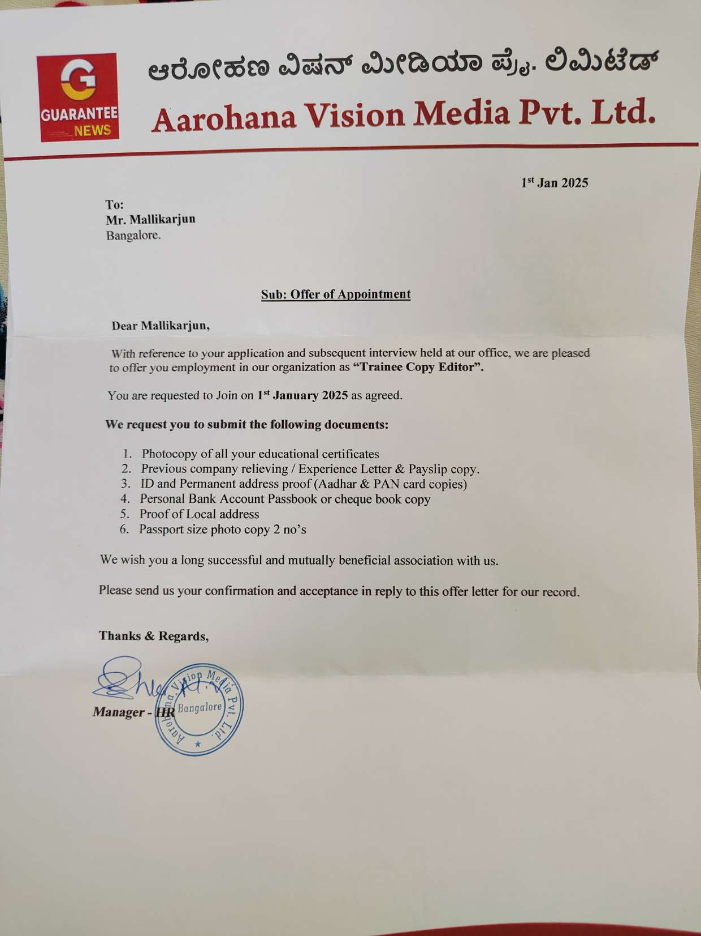

1st Nov 2024
To:
Mr. Mallikarjun
Bangalore.

Sub: Offer of Appointment

Dear Mallikarjun,

With reference to your application and subsequent interview held at our office, we are pleased to offer you employment in our organization as "Copy Editor".

You are requested to Join on 1st November 2024 as agreed.

We request you to submit the following documents:

- Photocopy of all your educational certificates.
- Previous company relieving /Experience Letter & Payslip copy.
- ID and Permanent address proof (Aadhar & PAN card copies).
- Personal Bank Account Passbook or cheque book copy.
- Proof of Local address 6. Passport size photo copy 2 no's

We wish you a long successful and mutually beneficial association with us.

Please send us your confirmation and acceptance in reply to this offer letter for our record.



